**Exploring Weather Trends**

Steps taken to produce the visualization – the only tool that was used for this is **excel**.

1. **Data Extraction**

Extraction of data (csv files) were done using SQL on the workspace

1. Global – SELECT year, avg_temp FROM global_data;
2. Local
   1. select * from city_list where country = 'India'; was used to find the closest city where I live and found bangalore seems to exists in the db.
   2. SELECT year, avg_temp FROM city_data WHERE city = 'Bangalore';
3. **Data** **Clean-up -** Missing temperature data on city_data is fixed using mean value replacement.
4. **Data merge** - Global/Local were done using text/csv import in excel. During this process 1796-1809 years and 2014, 2015 data which missing in local data were removed before the analysis graph was prepared.
5. **Moving Average** – 10 years moving average data was performed on both local and global data. Last 10 year average data is considered for formulation. Ie =AVERAGE(B51:B62) and every row will have an increment on the B column mentioned in the formula.

Below is the line chart comparison produced using Excel.

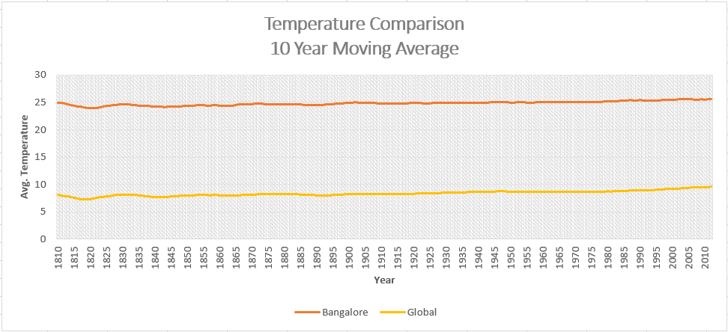

Observations

1. Bangalore weather is nearly 3 times of the global weather
2. Between 1810-1830, there is a decrease in the temperate both in Global and Local weather.
3. Between 1920-2010 there is an alarming increase in the temperature on global weather, which is little notable in Bangalore weather.
4. Below graph with global temp multiplied 3 times to get a clear visuals about the differences is performed – this clearly indicates the decrease in weather between 1810-1830, has very little contribution from bangalore weather, the same for the increase between 1920-2010.

